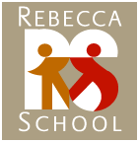

Rebecca School Annual Physical Instructions
Magnus is a medical database that Rebecca School uses to keep track of staff medical records. You will be asked to upload these documents which include an annual physical completed within the last 12 months, full immunization record, and PPD/TB test within the last 6 months.
Please be sure to upload all required medical documents within the first two weeks of employment.

You will receive an email from the school nurse to your Rebecca School email address with your account information for Magnus.

Attached you will find a copy of the annual physical form.

If you have any questions, please email the school nurses:
Theresa Millerschoen (tmillerschoen@rebeccaschool.org) and Kayla Garcia (kgarcia@rebeccaschool.org).

Thank you,
Latanya Jackson

Business Manager
Rebecca School

Latanya.Jackson@rebeccaschool.org
(212) 810-4120

